**Installation of WIRESHAEK software**

**LAB # 03**



**Spring 2022**

**CSE303L-Data Communication & Computer Network**

Submitted by: **Ashfaq Ahmad**

Registration No: **19PWCSE1795**

Class Section: **B**

“On my honor, as student of University of Engineering and Technology, I have neither given nor received unauthorized assistance on this academic work.”

Student Signature: ______________

Submitted to:

**Eng: Faizullah**

April 20, 2022

**Department of Computer Systems Engineering**

**University of Engineering and Technology, Peshawar**

**CSE 303L: Data Communication and Computer Networks**

|  |  |  |  |  |
| --- | --- | --- | --- | --- |
| **Demonstration of Concepts** | **Poor(Does not meet expectation (1))**  The student failed to demonstrate a clear understanding of the assignment concepts | **Fair(Meet Expectation (2-3))**  The student demonstrated a clear understanding of some of the assignment concepts | **Good (Exceeds Expectation (4-5)**  The student demonstrated a clear understanding of the assignment concepts | **Score**  **30%** |
| **Accuracy** | The student mis-configured enough network settings that the lab computer couldn't function properly on the network | The student configured enough network settings that the lab computer partially functioned on the network | The student configured the network settings that the lab computer fully functioned on the network | **30%** |
| **Following Directions** | The student clearly failed to follow the verbal and written instructions to successfully complete the lab | The student failed to follow the some of the verbal and written instructions to successfully complete all requirements of the lab | The student followed the verbal and written instructions to successfully complete requirements of the lab | **20%** |
| **Time Utilization** | The student failed to complete even part of the lab in the allotted amount of time | The student failed to complete the entire lab in the allotted amount of time | The student completed the lab in its entirety in the al | **20%** |

**Credit Hours: 1**

## Objective(s):

* Install WIRESHARK.
* To know about the WIRESHARK.

## What Is Wireshark?

Wireshark is a network protocol analyzer, or an application that captures packets from a network connection, such as from your computer to your home office or the internet. Packet is the name given to a discrete unit of data in a typical Ethernet network.

Wireshark is the most often-used packet sniffer in the world. Like any other packet sniffer, Wireshark does three things:

1. **Packet Capture:** Wireshark listens to a network connection in real time and then grabs entire streams of traffic – quite possibly tens of thousands of packets at a time.
2. **Filtering:** Wireshark is capable of slicing and dicing all of this random live data using filters. **By applying a filter, you can obtain just the information you need to see.**
3. **Visualization:** Wireshark, like any good packet sniffer, allows you to dive right into the very middle of a network packet. **It also allows you to visualize entire conversations and network streams.**

## What Is Wireshark Used For?

Wireshark is a software protocol analyzer, or "packet sniffer" application, used for network troubleshooting (having performance issue) , analysis, software and protocol development, and education. As data streams travel back and forth over the network, the sniffer "captures" each protocol data unit (PDU) and can decode and analyze its content according to the appropriate RFC, or other specifications

**View:**

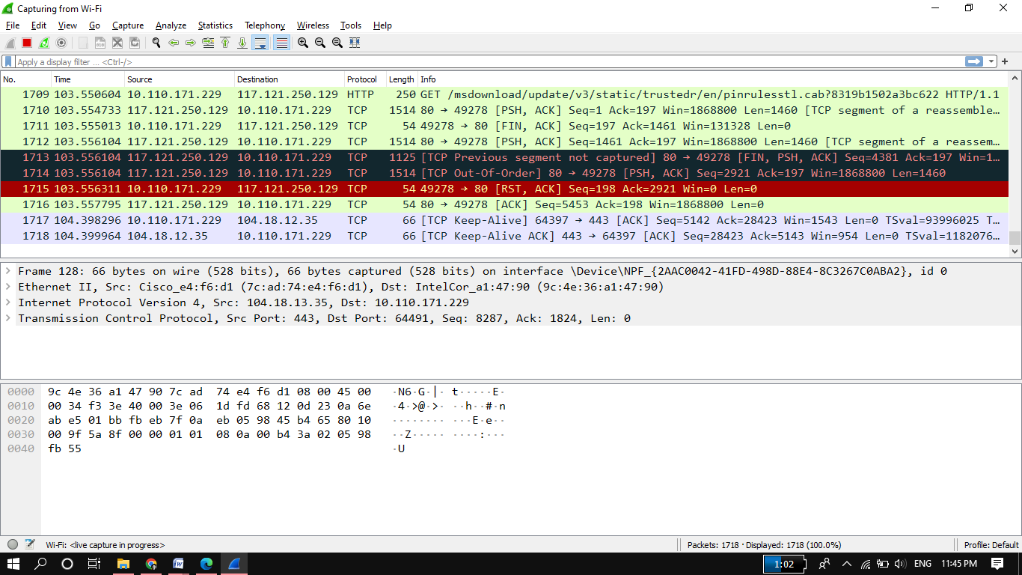

Figure 1: Viewing a packet capture in Wireshark

**Wireshark is a useful tool for anyone working with networks and can be used with most labs in the CCNA courses for data analysis and troubleshooting. This lab provides instructions for downloading and installing Wireshark.**

# Steps of Installation:

1. The downloaded file is named Wireshark-win64-x.x.x.exe, where x represents the version number if you downloaded the 64bit version. Double-click the file to start the installation process.

Respond to any security messages that may display on your screen. If you already have a copy of Wireshark on your PC, you will be prompted to uninstall the old version before installing the new version. It is recommended that you remove the old version of Wireshark prior to installing another version. Click **Yes** to uninstall the previous version of Wireshark.



1. If this is your first time to install Wireshark, or after you have completed the uninstall process, you will navigate to the Wireshark Setup wizard. Click **Next**.

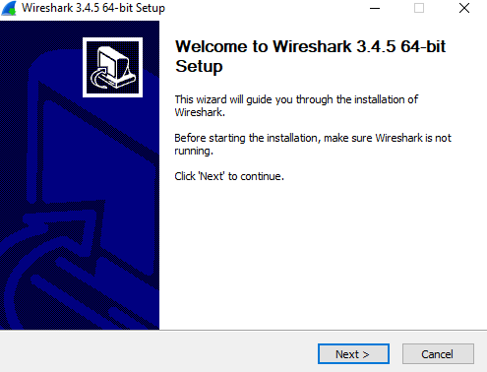

1. Continue advancing through the installation process. Click **I Agree** when the License Agreement window displays.
2. Keep the default settings on the Choose Components window and click **Next**.

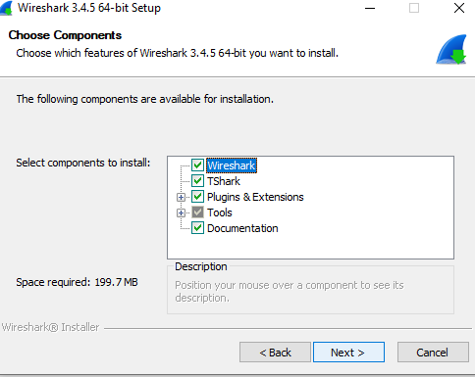

1. Choose your desired shortcut options and click **Next**.

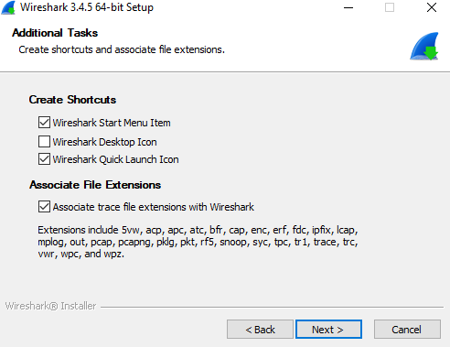

1. You can change the installation location of Wireshark, but unless you have limited disk space, it is recommended that you keep the default location. Click Next to continue.

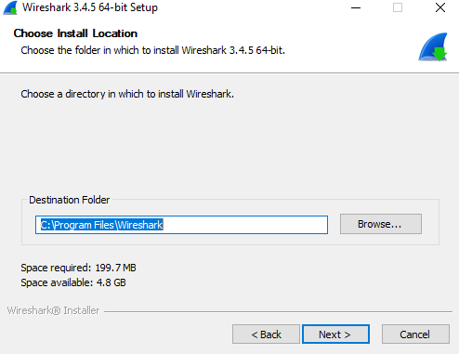

1. To capture live network data, Npcap must be installed on your PC. If Npcap is already installed on your PC, the Install check box will be unchecked. If your installed version of Npcap is older than the version that comes with Wireshark, it is recommended that you allow the newer version to be installed by clicking the Install Npcap x.x.x (version number) check box. Click **Next** to continue.

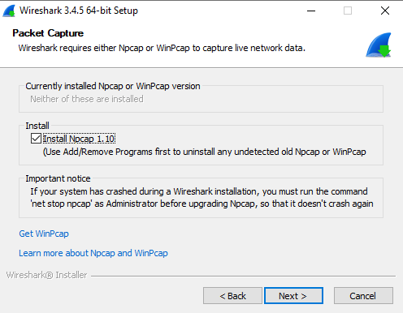

1. Do NOT install USBPcap for normal traffic capture. Do NOT select the checkbox to install USBPcap. USBPcap is experimental, and it could cause USB problems on your PC. Click Install to continue.

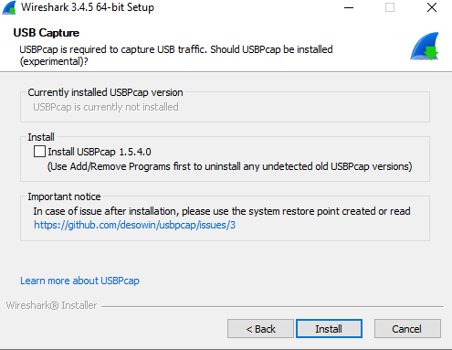

1. Wireshark starts installing its files and displays with the status of the installation.

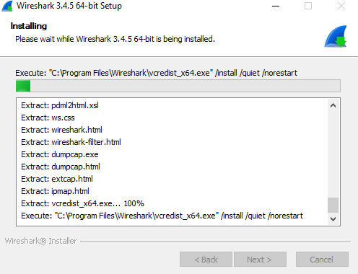

1. In a separate window, accept the license agreement in the Npcap Setup Wizard if installing Npcap. Click **I Agree** to continue. Click **Install** to install Npcap. Click **Next** to finish the Npcap installation and click **Finish** to exit the Npcap installation.

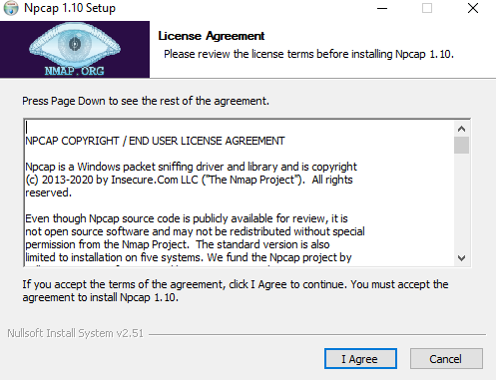

1. Click **Next** when the Wireshark installation is complete.

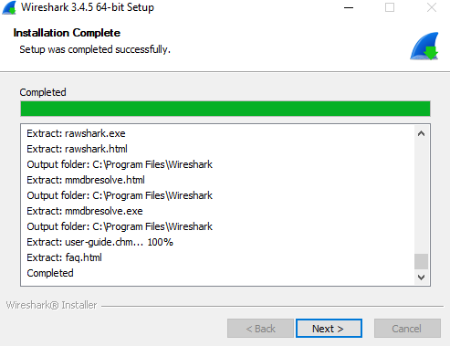

1. Click **Finish** to complete the Wireshark install process. Reboot the computer if necessary.

